Networks 3 – Lab 3 – Extended ACLs – Sept 2024

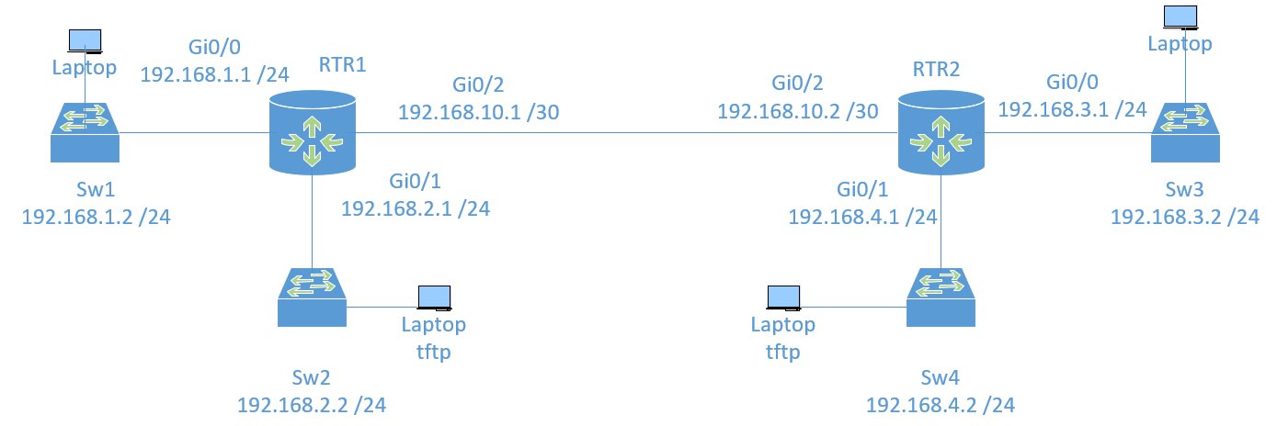
Figure 1: Lab 4 Layout
Configure the network as shown. You can use the switches and your laptops as test platforms for the ACLs. When finished – submit this lab as yourname_lab3.docx
- Network 1 – 192.168.1.0 /24
- Network 2 – 192.168.2.0 /24
- Network 3 – 192.168.3.0 /24
- Network 4 – 192.168.4.0 /24
- Network 5 – 192.168.10.0 /30
On each router do the following:
Part 1:
a. Create a local user with the username Admin and the encrypted password Pass-12345
b. Use PMcD-lab.com as the domain name.
c. Generate crypto keys using a 1024-bit modulus.
d. Configure the first five VTY lines on each device to support SSH connections only and to authenticate to the local user database.

You can cut and paste the following 3 commands into your Switches after you have renamed them as per the diagram above:
username Admin password Pass-12345
ip domain-name PMcD-lab.com
crypto key generate rsa

When asked, choose 1024 as the modulus. Then, continue with the next three commands.

line vty 0 4
transport input ssh
login local
exit

Task 1:
User 1 on RTR1- Create an extended ACL 101 that allows computers 0-31 in Network 3 to ssh to SW1. This means that you will need to have configured the line vty lines on the switch with a password of Pass-12345. You will prevent all other hosts from networks 3 & 4 from being able to ssh to the Switch. No other traffic will be affected. Test the operation.
Write the ACL that you configured here, and where you grouped it, here:

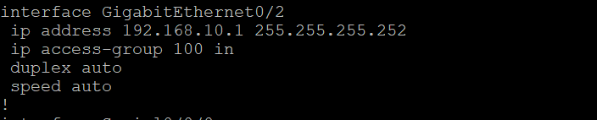

Note – We added a default static route
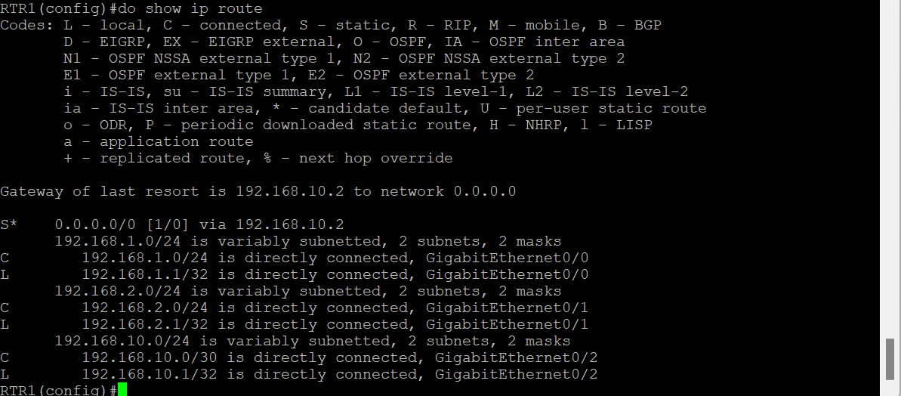

Testing SSH
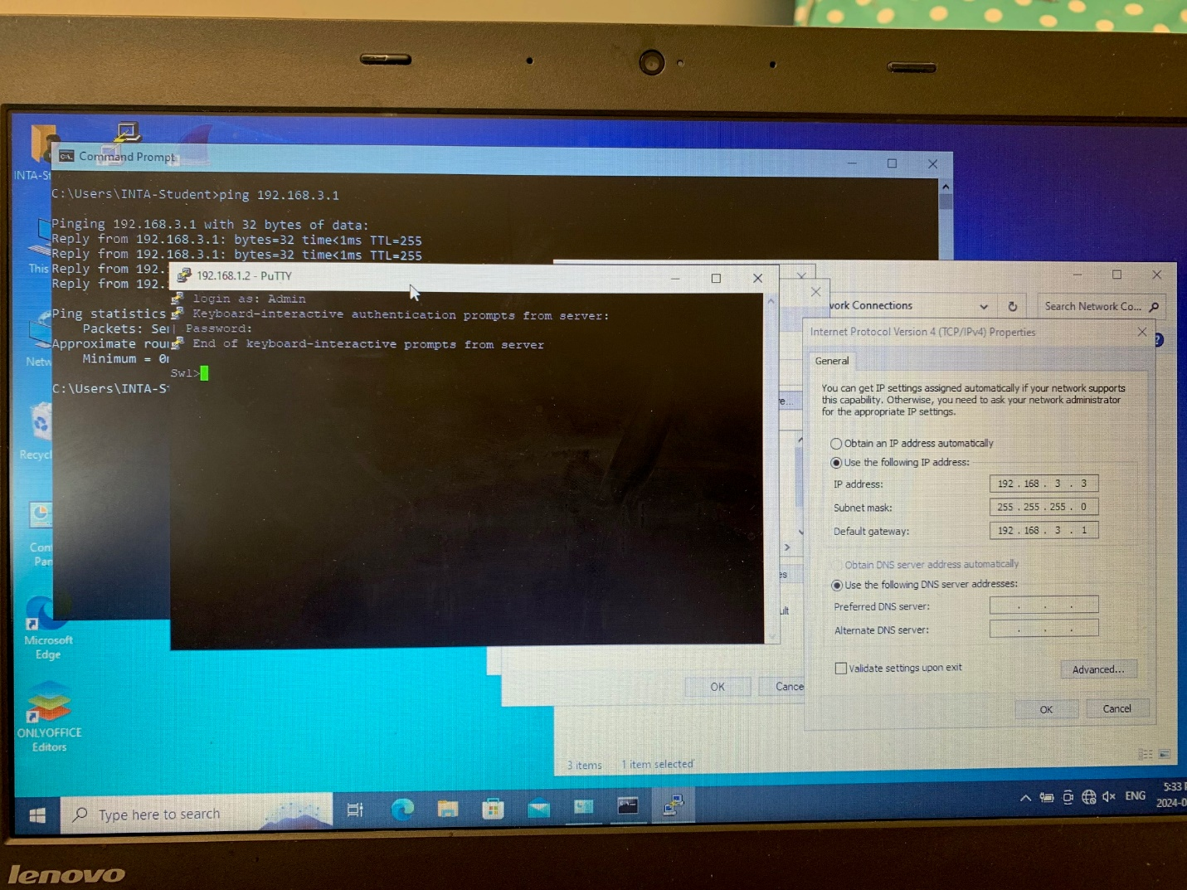

User 2 On RTR2 - Create an extended ACL 121 that permits computers .64-.71 in Network 2 to ssh to SW4. This means that you will need to have configured the line vty lines on the switch with a password of Pass-12345. You will prevent all other hosts from networks 1 & 2 from being able to ssh to the Switch. No other traffic will be affected. Test the operation.
Write the ACL that you configured here, and where you grouped it, here:

Testing SSH from 192.168.2.65 to access Sw4 192.168.4.2
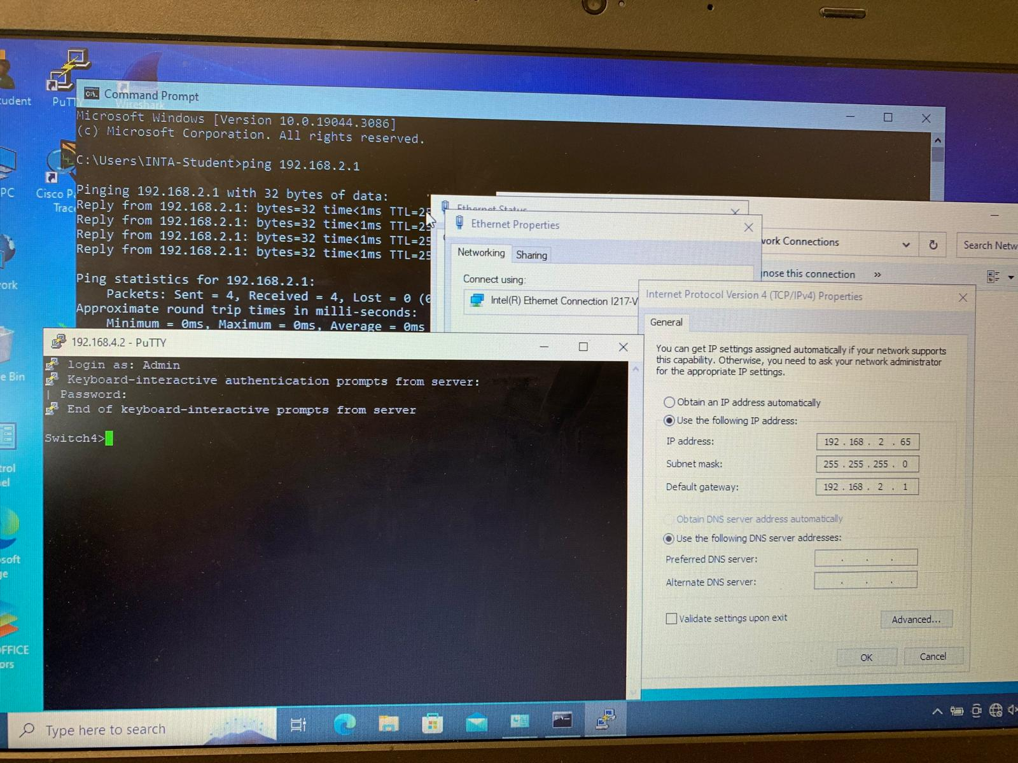

Task 2:
User 1 – Create ACL # 102 with an entry that prevents computers 192.168.1.128 - .131 of Network 1 reaching computers 192.168.2.0 - .15 of Network 2. No other traffic should be affected. Test the operation. I am not asking you to filter ICMP protocols, we are just using ping to verify that we can reach another device.
Write the ACL that you configured here, and where you grouped it, here:
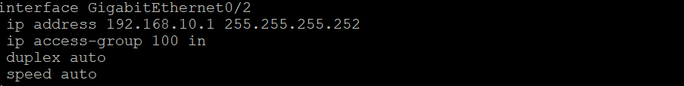
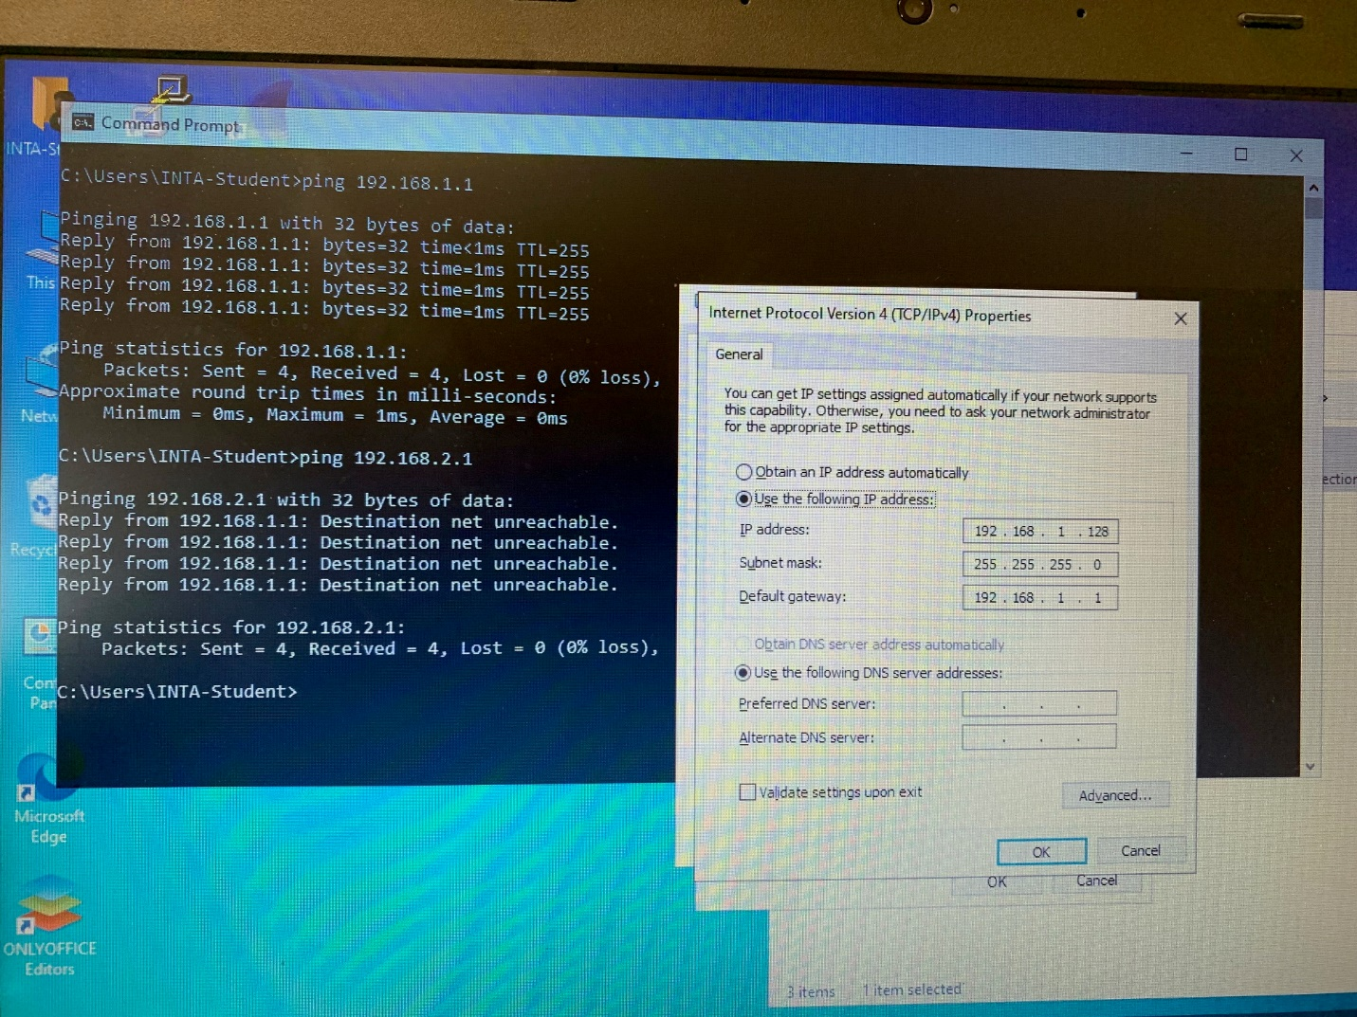
User 2 - Create ACL # 122 with an entry that prevents computers in 192.168.3.64 - .67 of Network 3 to ping (or reach) computers 192.168.4.16 - .19 of Network 4. No other traffic should be affected. Test the operation. Note: I am not asking you to filter ICMP protocols, we are just using ping to verify that we can reach another device.
Write the ACL that you configured, and where you grouped it, here:

Task 3: IF WE HAVE TIME
User 1 – You should have tftpd running on a laptop in one of your networks. Create an ACL 103 that permits only hosts 192.168.1.0 – 192.168.1.9 inclusive to be able to tftp to the laptop in network 2 which is running tftp. Use your switch in Network 1 to test this by running the command copy run tftp on the switch. Ensure that this ACL is not denying other traffic which should be allowed.
To run tftpd64, click on the tftpd64 icon and select “run as administrator”
Write the ACL that you configured here, and where you grouped it, here:

User 2 – You should have tftpd running on a laptop in one of your networks. Create an ACL 123 that permits only hosts 192.168.3.7 – 192.168.3.12 inclusive to be able to tftp to the laptop in network 4 which is running tftp. Use your switch in Network 3 to test this by running the command copy run tftp on the switch. Ensure that this ACL is not denying other traffic which should be allowed.
To run tftpd64, click on the tftpd64 icon and select “run as administrator”
Write the ACL that you configured here, and where you grouped it, here:

When finished, save your work as yourname_Lab3.docx and submit it to the proper Dropbox folder.

